Lab 3 – Web Server and Designing Web Pages

**Task 1: Creating database as per signup page of website.**

Create a database and a table to store data of users provided during signup.



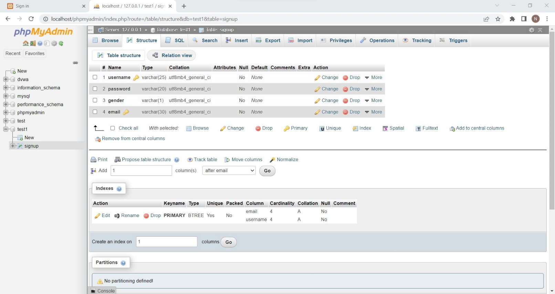

**Task 2: Store data in database during signup and authenticate users.**

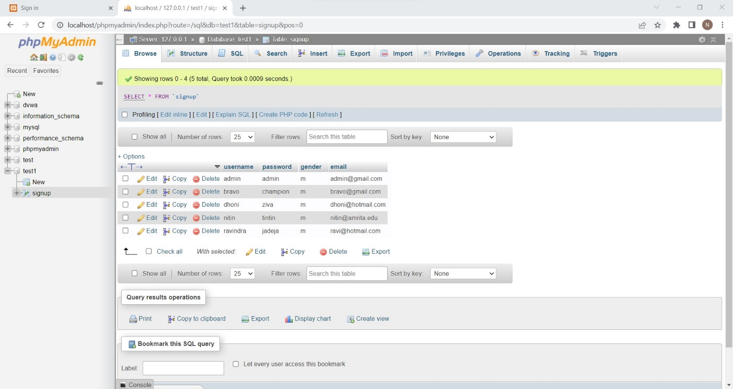Signup for at least 5 users and show data stored in database. You should also show the use of primary key and error thrown when primary key is repeated. Also authenticate the users before they login and show error when credentials are wrong.

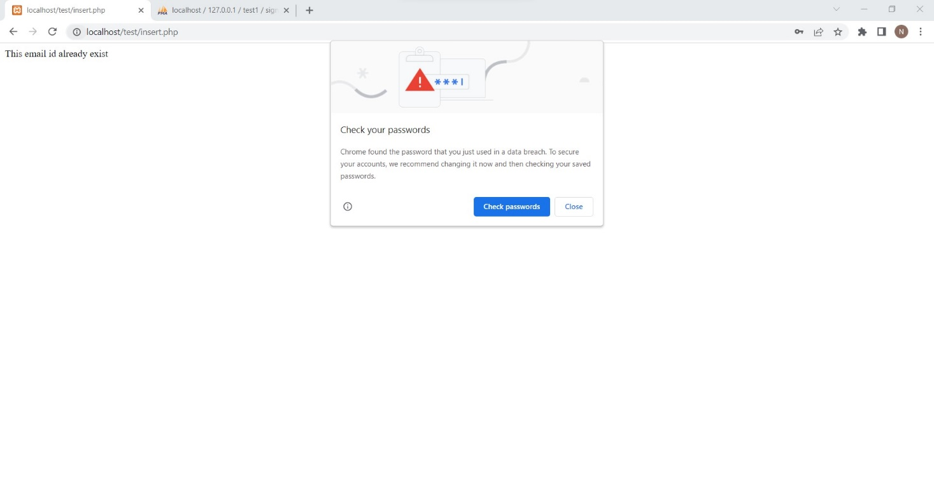Primary key repeated

If credentials are correct



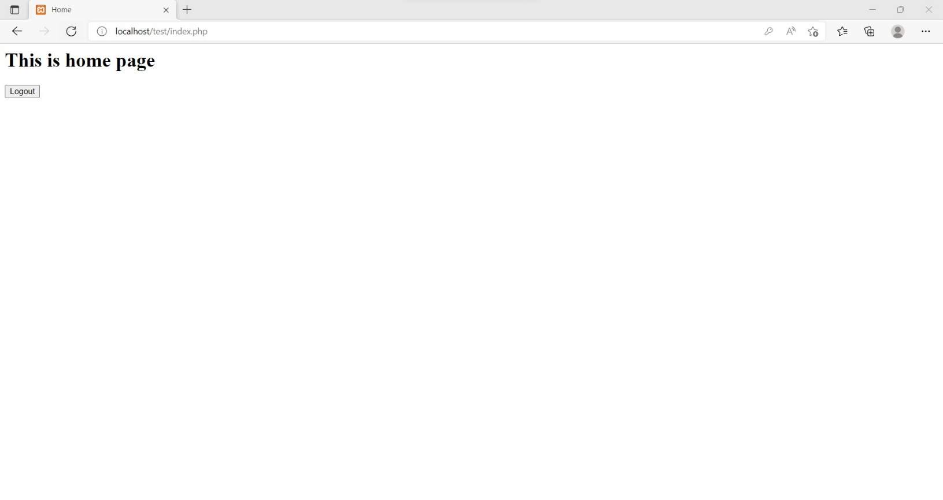

**Task 3: Session Management**

Create a session when user is authenticated. Session should be active until user logout from the website. Once the user logout, the session should be invalidated.

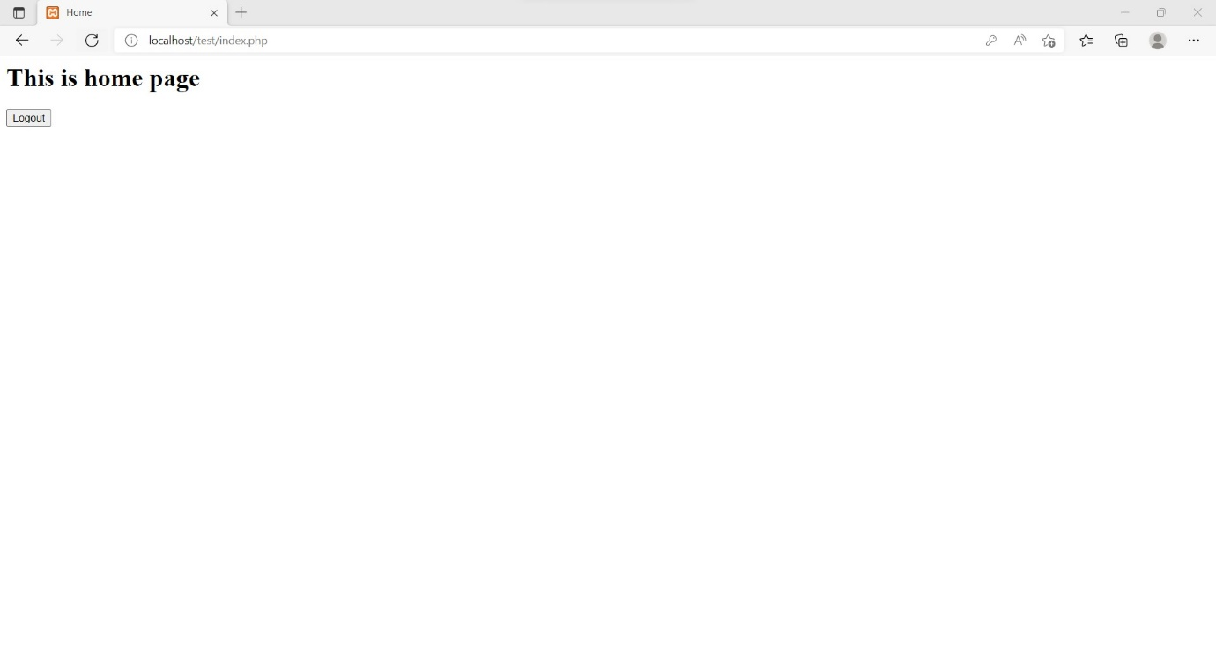

**Task 4**

